Shabbos Stories for
Parshas vayechi 5781
Volume 12, Issue 18 18 Tevet/January 2, 2020
Printed L’illuy nishmas Nechama bas R’ Noach, a”h

For a free subscription, please forward your request to keren18@juno.com
Past stories can be found on the website ShabbosStories.com

The Holy Shopkeeper
By Elchonon Isaacs

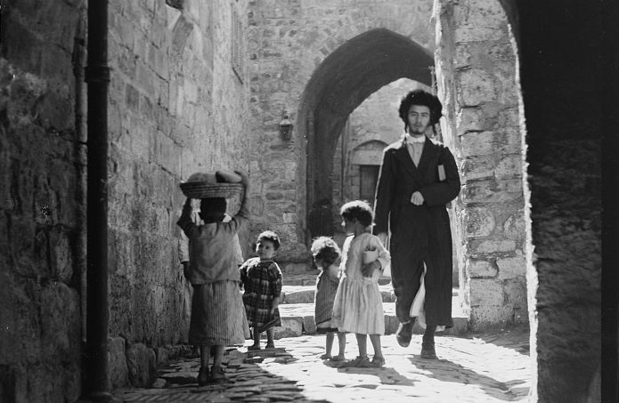
A typical Jerusalem Old City street scene in the 1920s (Library of Congress).

Reb Berel Bieber, my grandmother's father, was a widely respected Chabad Chassid, a diligent student of Torah, and a kindhearted man who took an active role in community affairs. He lived in Novozybkov, Belarus, where he provided for his family from his small business.
In 1890, Reb Berel chose to immigrate with his family to the Holy Land. To facilitate this, he first went alone to lay the groundwork for a smooth transition. He joined a new religious settlement in the Hadera region, where the main source of work was draining swamps.
The pioneers greatly respected him, as draining swamps was dangerous and difficult work, and at the end of the long day of manual labor he would immerse himself in Torah study. Reb Berel never complained; on the contrary, he was wont to say, “Thank G-d for allowing me to work the earth of the Holy Land.”
After a few weeks, Berel came down with a high fever and was hospitalized. With the tireless efforts of the doctors and nurses, he was saved. When he recovered, the doctor ordered him to either return to Russia or move to Jerusalem, where the air quality was better than the marshy swampland. Reb Berel was pained that he'd have to leave working the earth, which he saw as a holy mission, but the doctor's order took precedence.

He Moved to Jerusalem
Returning to Russia was out of the question. He moved to Jerusalem and, in time, settled in the Old City. He acquired a small shop in the Muslim quarter, where he sold staples such as flour and sugar. The grains were imported from Odessa to the port in Jaffa, and from there to Jerusalem.
Once the business got off the ground, his wife and children joined him in Jerusalem. Reb Berel's grandson, the late Dr. Aryeh Shoshan, related:
During my childhood, I loved to hang around my grandfather's shop. I see him clearly, sitting at the counter, his face shining, immersed in a volume of Talmud.
When customers entered, they'd do so quietly, always with an excuse for “bothering” him. As soon as he noticed them, my grandfather would mark his place, close the Talmud, and serve them patiently and graciously.
One day, an inspector from the Ottoman regime, which ruled the Holy Land from 1517 to 1917, entered the store and handed my grandfather an official document stating that he owed an enormous sum of taxes. The inspector warned my grandfather that if he did not pay up by noon the following day, they would confiscate the store and its contents.

Calmly Returned to Learning His Talmud
As soon as the inspector left, my grandfather sat back down and returned to his Talmud as if nothing had happened. Astonished by his composure, I asked, “Did you hear what the person said?! They will confiscate your store tomorrow! He looked serious!” My grandfather looked at me with an ever comforting smile, “Worry not, the help of G-d comes in the blink of an eye.”
That night I could not sleep. Early in the morning, I returned to the store to witness with my own eyes how G-d would help.
It was eight o'clock, and I asked my grandfather, “What will be?” The answer was the same, “G-d's help can come in the blink of an eye.” And he returned to his study.
Ten o'clock came and went, then eleven, and I asked yet again, “What will be?” Still, I received the same answer. As the minutes ticked by, I felt my heart beating faster and stronger.
At 11:15 am, a city councilman burst into the store, and asked my grandfather in a desperate, panicked voice, “A platoon of Turkish soldiers just arrived without any advance notice and we have nothing to feed them. Perhaps you have a large amount of flour so we can bake some bread?” Grandfather deliberately closed his book and rose to serve his customer. The city official pressed, “Please! Quick, help save us all!”

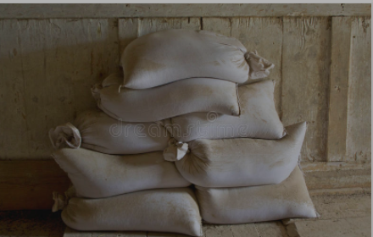

Grandfather got up and calmly went to the storage house behind the store. He piled up a few sacks of flour and brought them to the city councilman. The grateful bureaucrat hastily took out a wad of bills, paid for the flour, and left just as quickly as he had arrived.
My grandfather then walked to the government office a few blocks down and paid up his debt in full. When he came back, he sat down in his chair and resumed his learning, in the familiar tune, now with a slight smile on his face.
Indeed, I was privileged to witness how G-d's help comes in the blink of an eye.

Reprinted from the Parashat Vayeitzei 5781 email of Chabad.Org Magazine. Recorded by Aron Melamed of Haifa, a great-grandson of Reb Berel. Adapted and translated from the account published in Sichat Hashavua, vol. 569.
Judging Favorably #112
Not For My Son!
By Ruchoma Shain

Rivka was returning with her husband from a late wedding. It was after midnight, and as she got out of the car, she noticed two people on the other side of the street. She recognized her neighbor’s sixteen-year-old daughter, Toby, walking in the dark street with a young man, engrossed in conversation.
Toby did not realize that she had been seen. Rivka was shocked, as she was aware that Toby’s parents had gone away for the weekend. She had always had a high regard for the girl, who was a Bais Yaakov student and highly thought of in the community. Rivka decided not to divulge what she had seen.

A Shidduch Suggestion Avoided
About two years later, Rivka was approached by a relative of Toby’s who suggested that Toby and Rivka’s son were very suited for each other. Rivka, remembering what she had witnessed two years earlier, was evasive, claiming that her son was “busy.”
A few years passed, and neither Toby nor Rivka’s son had married. One day, Toby’s mother visited Rivka and asked her point-blank, “Are you against my daughter meeting your son?”
Rivka had no alternative but to tell her the truth, and Toby’s mother was astounded, not believing that her daughter would have had a clandestine meeting with a boy while she was away. She nevertheless approached Toby with the facts, and, sure enough, Toby recalled exactly what had happened.

The Explanation of the Post-Midnight Meeting
“Mommy, don’t you remember when cousin Dovid arrived unexpectedly from Israel, knocking at our door after midnight?” It was then that Toby’s mother recalled the innocent meeting. Dovid, her nephew, was on his way from Yerushalayim to a friend’s wedding in Chicago. His flight from Israel was delayed, and he could not make the connecting flight that night, so he decided on the spur of the moment to take a taxi from the airport in New York and spend the night with his aunt and uncle’s family. He was not aware that his aunt and uncle were away, of course, when he rang their doorbell so late at night.
Toby was very surprised to see her cousin from Israel standing in the hallway. She explained to him that he couldn’t stay in their home, as she was alone, but that she would find him other accommodations for the night. She called some close friends and when she explained the situation, they graciously offered to put him up for the night.
When Rivka had seen Toby walking with a young man on the darkened street after midnight, she was simply escorting her cousin to her friends’ home. When Rivka heard the truth of what had occurred, she was overcome with remorse that she had jumped to conclusions and asked Toby for her forgiveness.
Rivka’s son met Toby, and they were married within several months. A disaster was averted, but the repercussions of those few years that had plagued Rivka and delayed the marriage, was a potent message about jumping to conclusions and not judging people favorably. (“All for the Best” by Ruchoma Shain, Feldheim Publications.)

Reprinted from the Parshas Vayishlach 5781 email of The Weekly Vort.

The Dog’s Representative
In the Polish Parliament
By Rabbi Mordechai Kamenetzky

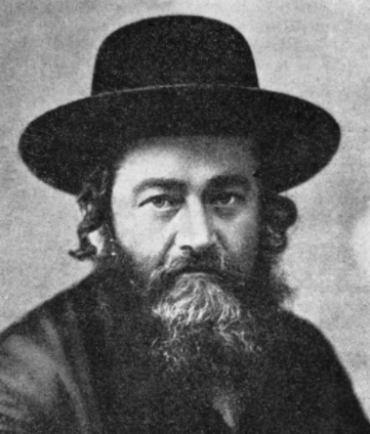

Rabbi Meir Shapiro (1887-1933) was a leader of Polish Jewry in the years before World War II. In addition to being the chief Rabbi of Lublin, building and maintaining one of the world’s largest and most beautiful yeshivos, Yeshivas Chachmei Lublin, he was also one of the first Orthodox members of the Polish parliament, the Sejm. He was a courageous leader whose vision and unwavering commitment to Torah values gained him the respect of Jews and gentiles alike.
During his first weeks as the leader of the Orthodox Jewish delegation, Rabbi Shapiro was approached by a Polish parliamentary deputy, Professor Lutoslawski, a known anti-Semite whose devious legislation constantly deprived minorities of their civil and economic rights.
Standing in front of a group parliamentarians in the halls of the Sejm, the depraved deputy began. “Rabbi,” he shouted, a sly smile spreading across his evil face. “I have a wonderful new way for Jews to make a living — they can skin dead dogs.”
Without missing a beat Rabbi Shapiro shot back. “Impossible, their representatives would never allow it.”
The Professor looked puzzled. “Whose representatives? The Jews’?”
“No,” smiled Rav Meir, “the dogs’ deputies.”
Flustered, the vicious bigot tried one more. “Well, my dear Rabbi,” he continued sarcastically. “Do you know that on the entrance gate of the city of Schlesien there is an inscription, ‘to Jews and dogs entrance forbidden?'”
Rabbi Meir just shrugged his shoulders. “If so, I guess we will never be able to visit that city together.”
Needless to say, nary an anti-Semitic word was ever pointed in Rabbi Meir’s direction again.

Excerpted from the December 1, 2020 edition of The JEWISH VUES.

Story #1199
Tehran Tanya Miracle
From the desk of Yerachmiel Tilles
editor@ascentofsafed.com
In 1978, The Lubavitcher Rebbe initiated a campaign to print the book of Tanya, the seminal work of Chabad Chassidic thought, in cities around the globe. To date (Nov. 2020), more than 7,500[1] editions of Tanya have been printed, from Azerbaijan to Zimbabwe.
About a year before the Revolution in early 1979, two emissaries of the Rebbe came to Iran in order to print the Tanya in Tehran, the capital city of Iran. The Jewish community there decided to print many copies of the Tanya in order to distribute them to the Jews of the city.
The Tanya was sent to be printed, but there were delays and it took a long time. In the meantime, in Feb. 1979, Ayatollah Khomeini overthrew the Shah ('king' in Persian), Mohammad Reza Pahlavi. R. Yehuda Ezrachian, who was responsible for the Jewish community's spiritual needs, arranged to remove all the copies of the Tanya from the printer in order to bring them to the community's library. There, in the large hall of the library, they were stored temporarily, in messy piles.

The New “Cleansing” Law
The new government announced a law, called 'cleansing,' stating that every Iranian citizen and all public organizations had thirty days in which to burn all the documents, papers, and books they owned that had on them the Shah's royal emblem, or even just his name, or anything connected to his reign. It ominously stated that after thirty days, anybody who possessed anything with one of these symbols would be severely punished. And if it was determined that he purposely did not destroy them, he would be executed.
R. Yehuda Ezrachian relates: "We faced a serious problem in that we had archives over a hundred years old, and most of the documents and books had the royal emblem on them, as well as the name of the Shah and his government. We also had a collection of special gold coins that the community produced in 1967 in honor of the king's coronation and in celebration of 2500 years since the coronation of Koresh[2]. On one side of the coin was a menorah and on the other side was either the royal emblem, the name Koresh or a crown.
"As Jews, it was very hard for us to accept the 'cleansing' of the entire valuable library and huge archive of our traditions, but we had no choice. Anyhow, clearly there was no way we could comply with the law in such a short time.

Two Government Inspectors Arrived
"When the month ended, we had not yet managed to complete the job, as expected. A day or two later, the secretary came into my office and said that two government inspectors had shown up to inspect the entire building, in order to see whether we had followed the cleansing law.
"I was terrifed. I understood that I was doomed and that the entire Jewish community was in great danger. I said Vidui (Confession) and Shma Yisrael, and prepared myself for what I knew was coming.
When the inspectors entered my offce, I was able to outwardly remain calm. For some reason, and still to this day I can't explain why, it occurred to me to take them first to the library.
"They immediately noticed the piles of books that were strewn all over. One of the inspectors bent over and picked one up. It was a Tanya! He asked me what it was, and I told him first about the author, about the Baal HaTanya, then about the Chabad movement, the Baal Shem Tov and Chassidut. I also said that this book was one of the primary texts of the movement.

The Inspector Opened the Tanya at Random
"He opened it at random and asked me to explain to him what it said on the page he had opened to. It was the ?rst page of Book Two, Shaar HaYichud V'HaEmuna. I translated into Persian and explained the entire page.
"When I was done, the inspector closed it, kissed it, and said, 'In a place with books like these, and with such a person in charge of a place like this, there is no need for any additional inspections.'
"We were stunned. When I recovered from this unexpected but very pleasing shock, I said to him that we would be extremely happy if he would sign our guestbook before he left. He agreed with a smile, and wrote: 'On such-and-such a day, I visited the offices of the Jewish community, and inspected and ascertained that all was as it should be.'"
The following Shabbat, in shul, the entire Tehran Jewish community celebrated with R. Yehuda Ezrachian the miracle that took place in the merit of the Tanya.

Footnotes:
[1]My primary source for the story was published in 2012, and there the number was "nearly 5000."
[2]'Cyrus' - founder of the first Persian empire. The king after him was Achashveros of Purim notoriety. Korush's relationship to the Jews is discussed in the Book of Ezra 1:3.)

Source: Adapted by Yerachmiel Tilles from an interview with R. Yehuda Ezrachian in Kfar Chabad Magazine, as translated on chabadmanhattanbeach.com/2639065 (and with a bit of the editing of Michoel Dobry in the Beis Moshiach version).
Connection: Seasonal -- This Shabbat is Yud Tes Kislev, the Chasidic festival celebrating (in reverse chronological order) the miraculous release of the first Chabad Rebbe from Czarist prison in 1798, the first printing of Tanya in 1796, and the passing of the Rabbi Dov-Ber, the Maggid of Mezritch, successor to the Baal Shem Tov, in 1760; all three events happening on the same date, the 19th (yud-tet) of the Jewish month of Kislev.

Reprinted from the Parshat Vayeitzei 5781 email of KabbalaOnline.org, a project of Ascent of Safed.
The Tzemach Tzedek
And the Aguna
By Rabbi Tuvia Bolton

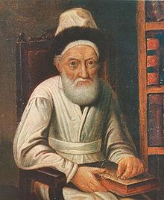

Here is a story about Rebbe Menachem Mendel Schneersohn, 1789-1866 (nicknamed 'The Tzemach Tzedek') the third leader of the Chabad Movement some 150 years ago in Russia, that may help us understand.
Once there was an Aguna searching for a solution to her problem. An 'Aguna' is a married woman whose husband disappears. Such a woman cannot remarry until there is either proof of the husband's death or he is located alive and gives a bill of divorce.
This Aguna had been estranged for several years with two children and no clue as to her husband's whereabouts. At first his absence was a bit of relief to her. He had been a strange fellow with an occasional streak of violence. But after a few years on her own it suddenly hit her; he wasn't going to return. She was still a young woman and the burden of providing for herself and her children alone for the rest of her life would be torture.
So she began to take action. She sent letters and traveled from Rabbi to Rabbi with her sad story but with no results.
Then, one day there was a breakthrough! Two religious Jews knocked on her door, introduced themselves by name, and told her that the reason her husband did not return is because several months ago he got sick and died! They had even been present at his funeral.
On his sick bed, as he was dying, he gave them her name and address and made them promise to inform her so she could remarry. They apologized that it took them so long but it was a long journey and a big trouble for them so they kept pushing it off.

Wept Tears for Her Dead Husband and Relief for Herself
When she digested the news, she covered her eyes and wept tears of woe for her dead husband and of relief for herself.
The men suggested that they go immediately to a Rabbi and give their testimony so she could be free to remarry and they could return home.
They went together to the local Rabbi who gathered several other Rabbis to verify the testimony and after an hour of questioning they began writing a statement that she was a widow and could remarry. But just as they were finishing, an old Rabbi who had been sitting unnoticed in the corner of the room learning Talmud, stood, raised his hand for them to stop and declared, "Don't let her marry!"
All eyes turned to him. It was the well-known 'Tzadik' of the town (names were not given in the story); a holy Jew with a long white beard and kind, deep eyes whose every word was tried and trusted to never miss the mark.
"I 'see' that he is still alive! I can 'see' him!" The judges stared at the Tzadik with wide eyed astonishment and then turned to the Rabbi of the town who shrugged his shoulders and said. "We can't continue until this is clarified!" And the court was dismissed.

The Aguna Wasn’t Going to Give Up So Easily
But the aguna wasn't going to give up so easily. She knew that according to the Torah, testimony of two reliable eye-witnesses is always sufficient â€¦. whereas prophetic 'vision' NEVER is.
She had suffered too long to just give up. She decided to go to another bigger Rabbi! The 'Tzemach Tzedek' of Chabad.
A day later she and the two witnesses were in the city of Lubavitch standing before him. He asked a few questions and then called three more judges to form a judicial court and together they solemnly heard all the testimony including the opinion of the visionary rabbi in her home town.
They asked almost the same questions as the first judges did, nodded their heads in agreement, said that apparently there was no reason she could not remarry and then turned to the Tzemach Tzedik for his okay.
The Rebbe thought for several moments, raised his gaze to the ceiling as though deep in contemplation, smiled, looked at the judges and finally nodded in agreement. "I see no reason why she can't remarry".
Again she broke out crying tears of relief. Within an hour a document was written up and signed by the judges and witnesses, that her husband was dead and she could marry.
Several months later she found a match! And several weeks after that she remarried and began life anew. Mazal Tov!!

A Few Days After the Wedding
But one afternoon a few days after the wedding there was a knock at her door and she opened to see two religious Jews. They introduced themselves, asked her name and her (previous) husband's name, asked if they could come in and sit down and then gave her shocking news.
They had been with her husband in a distant country when he got sick and passed away ... two weeks ago!!
"TWO WEEKS??" She said in disbelief and staggered backwards. "But I was told he died months ago! There were witnesses!"
"Yes" They replied. "That's why we are here. That was a lie!
"He died only a few weeks ago. We were with him. But before he died, he confessed to us that several months earlier he had paid two Jews to travel to you and falsely testify that he was dead. He wanted you to do a sin and marry someone else while still married to him!
"He said that he had left Judaism and it gave him a particular pleasure to make others do the same! But now that he was dying, he realized he was wrong and wanted to repent. So he sent us here to tell you."

Her Mind was Spinning
Her mind was spinning! Two weeks ago! In other words, the first 'seeing' Rabbi had been correct! Her first husband really had been alive! If she had married back then it would have been a catastrophe!
And not only that but it seems that the Tzemach Tzedek was wrong! It was a miracle that her second marriage delayed till after he really died!
The story got around and when the first 'visionary' Rabbi heard what happened he immediately traveled to the Tzemach Tzedek to hear his explanation; how could the holy Lubavitcher Rebbe have given the okay for her to marry when in fact at that time, it had been FORBIDDEN
Could it be that the Rebbe didn't 'see' properly? Or, even worse, perhaps he CAUSED the man to die in order to save the woman from doing a sin?
"No" The Tzemach Tzedek answered matter-of-factly. "I just saw that everything would turn out according to the Torah. That, in fact, she would marry after he died.
"In fact, he killed himself! By falsely declaring to the first false witnesses that he himself was dead he actually caused it to happen! Not only that, but his death saved his wife, his two lying witnesses, her second husband and even himself from sinning.

Reprinted from the Parshat Lech Lecha 5781 email of Yeshiva Ohr Tmimim in Kfar Chabad, Israel.

The Woman’s Segulah to Recite Certain Perakim of Tehillim (Psalms)

Rabbi Ephraim Eliyahu Shapiro told an amazing story about a woman in her 40’s who hadn’t yet found her zivug—match. A friend of hers suggested she go to Rav Yissachar Meyer to get some advice. The woman was from France and didn’t speak Hebrew, so she asked her friend to help translate the rabbi’s message to her. The rabbi suggested to the woman to read tehillim— to “recite perek 32, perek, 38, perek 82, and perek 121 every day for 30 days.” The friend translated this for the single woman, and she vowed to do just that.
On day 30 she got engaged, and she asked her friend to find the rabbi to share the amazing news! While they were getting in touch with the rabbi, the friend realized something.
She said to the new bride, “I know you don’t speak Hebrew, because I need to translate for you, but do you read Hebrew?”
The woman said, “No, of course not.”
he friend, dumbstruck, said, “Well, how did you say the four perakim for 30 days?”
The woman answered, “I did exactly what the rabbi said to do! I held the tehillim close to me, and I said with all my heart, ‘perek 32, perek 38, perek 82, perek 121, please Hashem send me a zivug,’ every day for 30 days.
The woman’s intention was to pray to Hashem with sincerity and emunah, and although her prayers weren’t exactly traditional, they were heartfelt prayers, nonetheless, and Hashem sent her a shidduch.

Reprinted from the Chayei Sarah 5781 email from Jack E. Rahmey based on Torah teachings of Rabbi Amram Sananes.

A True Chesed
By Rabbi Reuven Semah

Rabbi Finkelman illustrates with a true story that he heard from a friend:
“A neighbor of mine in Monsey was sitting shiva in Brooklyn after his father passed away. Because the shiva ended on Shabbat morning, he planned to return home on Friday afternoon so that his neighbors could visit him before Shabbat. I knew the house would be crowded and it would not be possible to have sa meaningful conversation with the mourner who was a good friend of mine.
“I decided to drive to Brooklyn so that I could fulfill the misvah in the optimum way. I went to visit him in Brooklyn and offered to drive him to Monsey, and he gladly accepted the offer.
“My friend told me, ‘I cannot explain how grateful I am to you. Had you not driven me back, I would have had to take the Monsey bus back home, and with my torn shirt and unkempt appearance, I would have been the object of many stares and disapproving looks. You saved me from all that.’

“When we arrived at his home, he blessed me with all his heart that he should not be able attend the weddings of my three daughters, all of whom were in shiduchim at the time, meaning that all three weddings should be held during the year of his mourning.

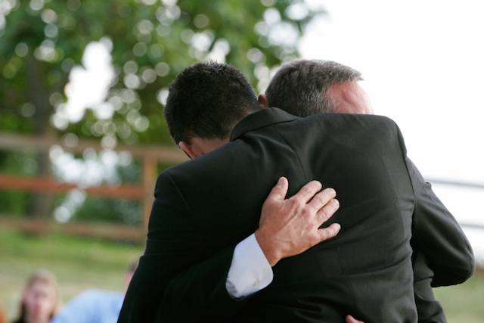

“This berachah was fulfilled. The last night of sheva berachot for the third daughter was held on the night after his father’s first yahrtzeit!
Such is the power of hakarat hatob.

Reprinted from the Parashat Vayishlah 5781 email of Shabbat Shalom from Cyberspace as compiled by Rabbi David Bibi. Originally published in the Jersey Shore Torah Bulletin.

